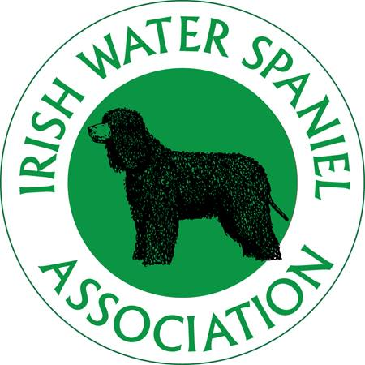
Irish Water Spaniel Association
Annual General Meeting 2022
Venue - Rowington Village Hall, Rowington Green, Warwick, CV35 7DB
Date 20th March 2022
Time 11.00am

Agenda
 | Agenda item | Facilitated by;
1. | Chairman opens the meeting. | Elizabeth Cooper
2. | Apologies | Angie Biggs
3. | Matters arising from the minutes.
4. | Chairman’s report | Elizabeth Cooper
5. | Secretary’s report | Angie Biggs
6. | Treasurer’s report | Allison McNaught
7. | To approve the 2021 accounts.
8. | To appoint an independent examiner for 2022 accounts
9. | Honoraria
10. | Welfare report | Lois Ferrans
11. | Health report from KC Breed Health Coordinator | David Wilcox
12. | Member’s proposals  None received. | N/A
13. | Result of ballot for the election of the President | Angie Biggs
14. | Result of ballot for the election of the Treasurer | Angie Biggs
15. | Result of ballot for the election of Executive Committee Members | Angie Biggs
16. | Result of ballot for the appointment of Judges for 2024 Championship Shows, 2023 Open Shows and Special Awards Judge for 2022 Championship Show. | Angie Biggs
17. | A.O.B. previously advised to the Secretary PRIOR to the meeting or any business on the day which, in the opinion of the Chairman, is deemed to be urgent.
18. | Close meeting | Elizabeth Cooper
A Presentation of the Annual Trophies will follow immediately after the AGM, which will be followed by a short break for Lunch.
We will then resume with an Open Meeting for Members to discuss the implications of the Breed Health and Conservation Plan (BHCP) and the pros/cons of the Breed’s Vulnerable status. We hope that all those who have bred a litter or are planning a litter or have a dog available for Stud will attend and contribute to this discussion to help us to establish what support the IWSA can offer you and your potential puppy buyers in the future. (please bring a packed lunch if you are staying)

