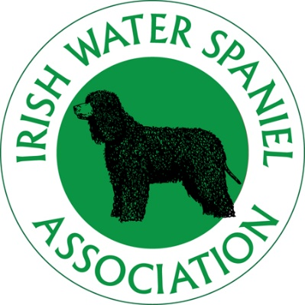
IRISH WATER SPANIEL ASSOCIATION
CRITERIA for INCLUSION on BREED CLUB
JUDGES LIST 2017

The criteria are based on the KC Advisory Criteria for the compilation of Breed Club Judges lists
(March 2013)

A1 List
For people who have previously been approved by the Kennel Club to award CC’s in Irish Water Spaniels, have completed their first appointment and have the support of the IWSA
A2 List
- For people who fulfil all the requirements for the A3 list, who have been
assessed in accordance with Kennel Club requirements and accepted by the
Kennel Club for inclusion on an A2 list, and have the support of the IWSA

- To have attended an Open Field Trial or an Open Gundog Test (GWT) retrievers.

3. A3 List (Breed Specialists)
Requirements include:
- Minimum of seven years judging experience in Irish Water Spaniels and have the support of the IWSA

- To have judged Irish Water Spaniels at 5 Open Shows or Championship Shows without CCs with an adequate geographical spread.

- To have judged a minimum of 20 classes of Irish Water Spaniels

- To have judged a minimum of 50 Irish Water Spaniels .

- To have attended a seminar given by a Kennel Club Accredited Trainer, and
passed the relevant examination on Kennel Club Regulations and Judging
Procedures.

- To have attended a seminar given by a Kennel Club Accredited Trainer on
Conformation and Movement.

- To have attended a Points of the Dog Assessment conducted by a Kennel
Club Accredited Trainer and passed the assessment

- To have attended at least one Irish Water Spaniel Specific Seminar run in accordance with the relevant Kennel Club Code of Best Practice and passed an examination and/or assessment.

- To have bred and/or owned a minimum of three dogs when they obtained
their first entry in the Kennel Club Stud Book (save in exceptional circumstances).

- To have stewarded at 12 Shows

- To attend an Open Field Trial or an Open Gundog Test (GWT) for Retrievers

3a. A3 List (Non-Breed Specialists)
Requirements include:
a. Minimum of seven years judging experience in any one breed (to include five
years in Irish Water Spaniels) and have the support of the IWSA.

b. To have judged Irish Water Spaniels at 5 Open Shows or Championship Shows
without CCs with an adequate geographical spread.

c. To have judged a minimum of 20 classes of Irish Water Spaniels.

d. To have judged 50 Irish Water Spaniels.

e. To have awarded CCs in at least one other breed.

f. To have attended at least one Irish Water Spaniels Specific Seminar run in accordance with the relevant Kennel Club Code of Best Practice and passed an examination and/or assessment.

g. To have bred and/or owned a minimum of three dogs of any breed when
they obtained their first entry in the Kennel Club Stud Book (save in
exceptional circumstances).

h. To have attended an Open Field Trial or an Open Gundog Test (GWT) for Retrievers

4. B List (Breed Specialists)
a. To have 5 years experience owning and exhibiting Irish Water Spaniels and have
the support of the IWSA

b. To have judged a minimum of 5 classes of Irish Water Spaniels at Open Shows or Championship Shows without CCs.

c. To have judged a minimum of 15 Irish Water Spaniels (This may include those judged at IWSA Assessment Seminar).

d. To have attended at least one Irish Water Spaniel Association Breed Specific Seminar run in accordance with the relevant Kennel Club Code of Best Practice and passed an examination and/or assessment.

4a. B List (Non-Breed Specialists)
a. Minimum of 5 years judging experience in any one breed and have the
support of the IWSA.

b. To have judged a minimum of 5 classes of Irish Water Spaniels at Open Shows or Championship Shows without CCs (save in exceptional circumstances).

c. To have judged a minimum of 15 Irish Water Spaniels (This may include those judged at IWSA Assessment Seminar).

.d To have attended at least one Irish Water Spaniel Association Breed Specific Seminar run in accordance with the relevant Kennel Club Code of Best Practice and passed an examination and/or assessment..

C LIST BREED SPECIALISTS AND NON-BREED SPECIALISTS

5. C List (Breed Specialists)
For aspiring judges who have owned/shown IWS for a minimum of 4 years or are able to demonstrate to the committee that they have had an active interest in the breed for 5 years, attended an IWSA Breed Specific Seminar run in accordance with the relevant Kennel Club Code of Best Practice and have the support of the IWSA.

5a. C List (Non-Breed Specialists)
For aspiring judges who are able to demonstrate to the committee that they have had an active interest in the breed for 5 years, attended an IWSA Breed Specific Seminar run in accordance with the relevant Kennel Club Code of Best Practice and have the support of the IWSA ,

